***Importing modules***

# Import pandas as pd

**from** sklearn.model_selection **import** train_test_split

**from** sklearn.linear_model **import** LinearRegression

**from** sklearn.metrics **import** confusion_matrix,accuracy_score

**from** sklearn.ensemble **import** RandomForestRegressor

***Reading the Dataset***

**import** pandas **as** pd

df**=**pd**.**read_csv("C:\\Users\\GPT BANTWAL\\AI&ML\\AABA_2006-01-01_to_2018-01-01.csv")

df

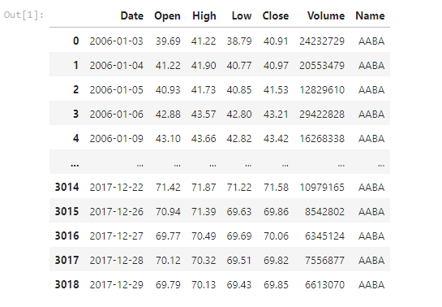

***check the five columns***

df**.**head()

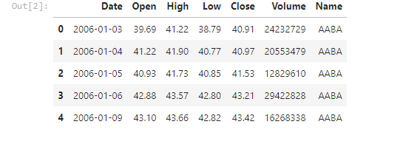

df**.**shape



*#Check the missing value*

df**.**isnull()**.**sum()

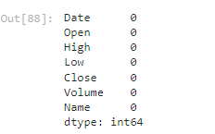

df**.**isnull()**.**any()

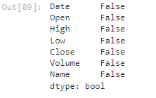

*#Checking the information Dataset*

df**.**info()

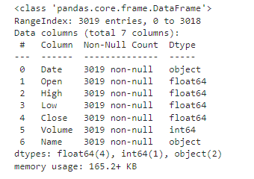

df**.**describe()

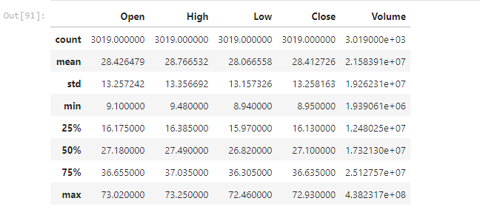

print('lenghth of dataset:',len(df))



*#Linegraph for stock Time Series*

**import** matplotlib.pyplot **as** plt

df['Low']**.**plot(figsize**=**(16,6))

plt**.**title('Linechart')

plt**.**xlabel('Low')

plt**.**ylabel('frequency')

plt**.**show()

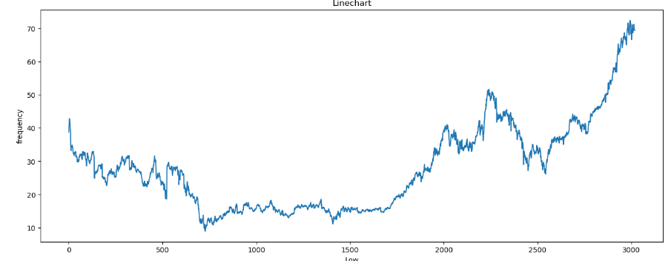

x**=**df**.**drop(['Open','Date','Name'],axis**=**1)

x

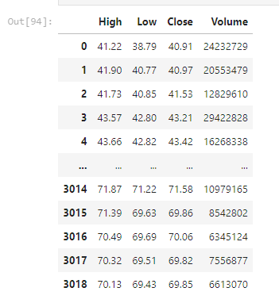

y**=**df['Open']

y

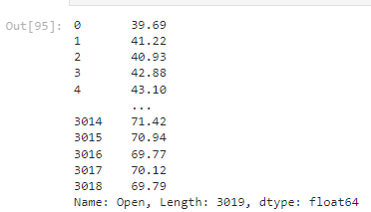

**from** sklearn.model_selection **import** train_test_split

x_train,x_test,y_train,y_test**=**train_test_split(x,y,random_state**=**0)

print(x_train**.**shape)

print(x_test**.**shape)

print(y_train**.**shape)

print(y_test**.**shape)

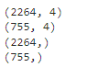

**from** sklearn.linear_model **import** LinearRegression

regressor**=**LinearRegression()

regressor**.**fit(x_train,y_train)



print(regressor**.**coef_)



print(regressor**.**intercept_)



*#Prediction*

predicted**=**regressor**.**predict(x_test)

predicted

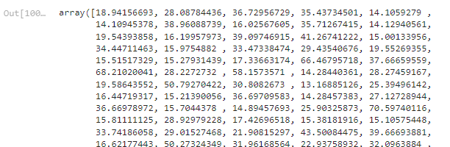

print(x_test)

print(x_test)

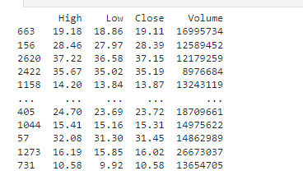

predicted**.**shape



dframe**=**pd**.**DataFrame(y_test,predicted)

dframe

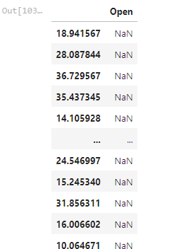

dfr**=**pd**.**DataFrame({'Actual Price':y_test,'Predicted Price':predicted})

dfr

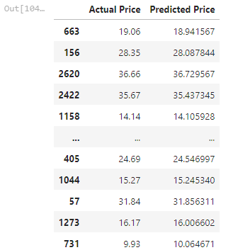

dfr**.**head(60)

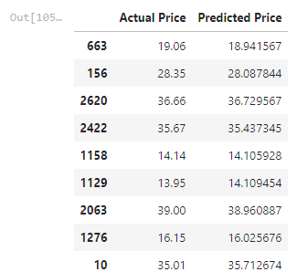

**from** sklearn.metrics **import** confusion_matrix,accuracy_score

train_accuracy**=**regressor**.**score(x_train,y_train)

print('train_accuracy:',train_accuracy)

test_accuracy**=**regressor**.**score(x_test,y_test)

print('test_accuracy:',test_accuracy)



**import** math

**from** sklearn **import** metrics

print('Mean Absolute Error:',metrics**.**mean_absolute_error(y_test,predicted))

print('Mean Squared Error:',metrics**.**mean_squared_error(y_test,predicted))

print('Root Mean Squared Error:',math**.**sqrt(metrics**.**mean_squared_error(y_test,predicted)))



graph**=**dfr**.**head(20)

graph

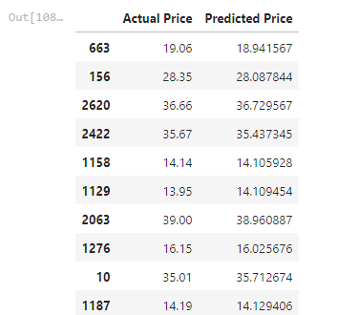

*#plotting the bargraph to check difference between actualprice and predicted price*

graph**.**plot(kind**=**'bar')

plt**.**title('BarGraph')

plt**.**xlabel('Actual&prediceted price')

plt**.**ylabel('frequency')

plt**.**show()

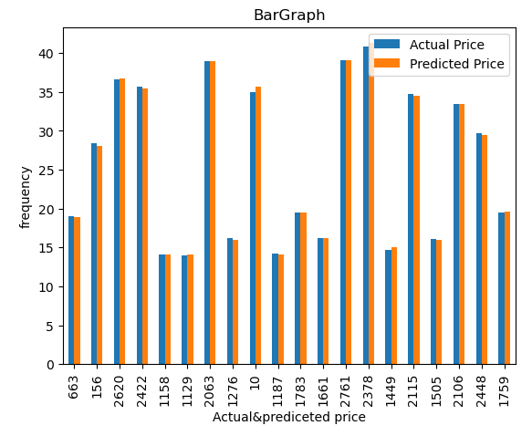

**from** sklearn.model_selection **import** train_test_split

x_train,x_test,y_train,y_test**=**train_test_split(x,y,test_size**=**0.90,random_state**=**100)

print(x_train**.**shape)

print(x_test**.**shape)

print(y_train**.**shape)

print(y_test**.**shape)

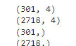

*#Model trainning*

**from** sklearn.ensemble **import** RandomForestRegressor

regressor **=** RandomForestRegressor(n_estimators**=**100,random_state**=**0)

regressor**.**fit(x_train,y_train)



predicted**=**regressor**.**predict(x_test)

predicted



*#Evaluating the model*

**from** sklearn.metrics **import** confusion_matrix,accuracy_score

train_accuracy**=**regressor**.**score(x_train,y_train)

print('train_accuracy:',train_accuracy)

R_test_accuracy**=**regressor**.**score(x_test,y_test)

print('test_accuracy:',R_test_accuracy)



*#Linear and Randomforestregression using bar plot*

**import** matplotlib.pyplot **as** plt

linear_regression_accuracy **=** 0.999700039585113

random_forest_accuracy **=** 0.998957807027415

accuracy_scores **=** [linear_regression_accuracy, random_forest_accuracy]

model_names **=** ['Linear Regression', 'Random Forest Regression']

plt**.**bar(model_names, accuracy_scores)

plt**.**xlabel('Regression Models')

plt**.**ylabel('Test Accuracy')

plt**.**title('Comparison of Test Accuracy: Linear Regression vs Random Forest Regression')

plt**.**show()

